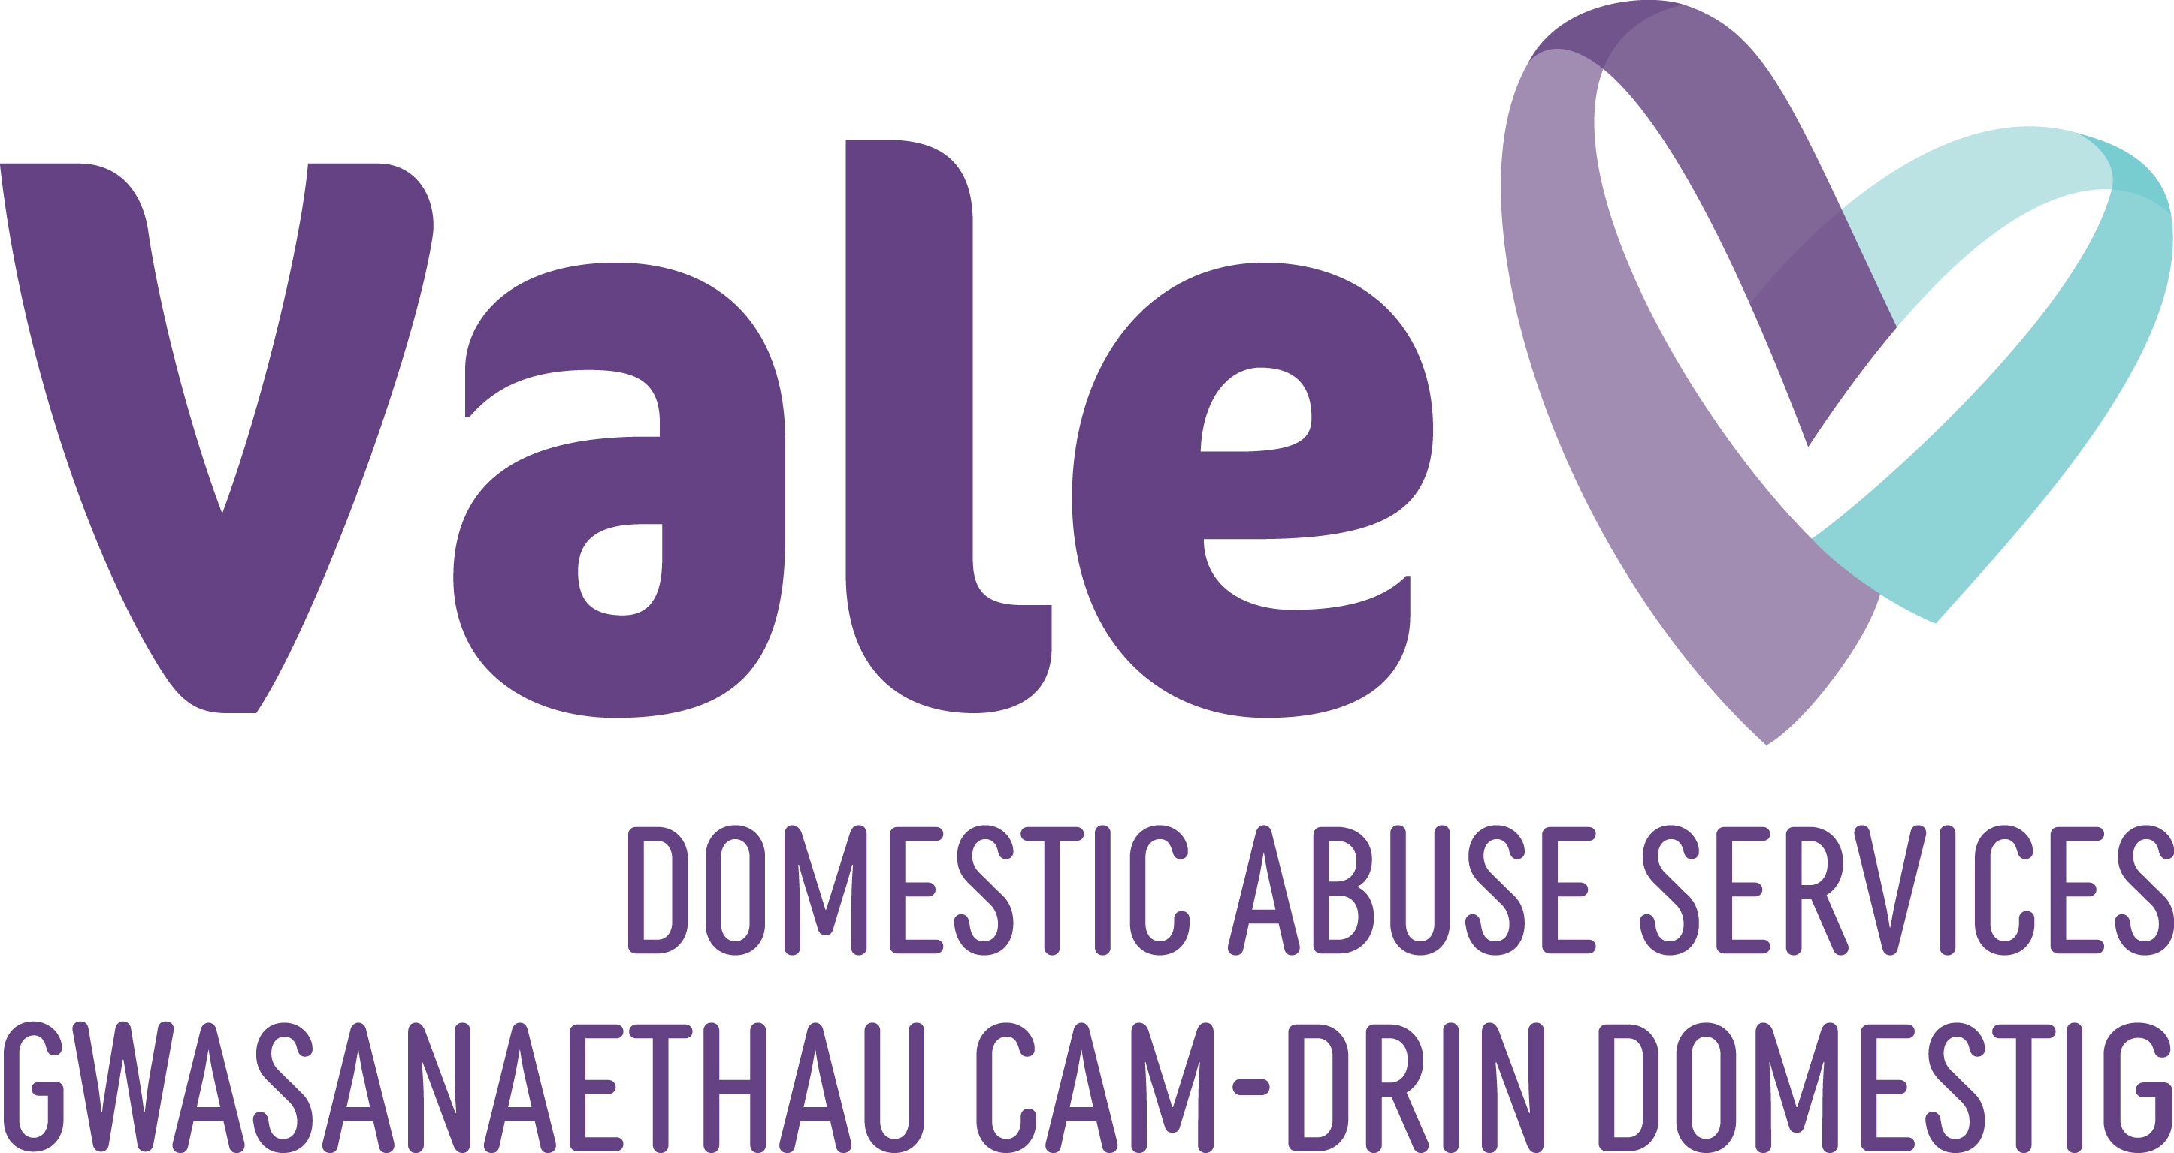

Trustee
Candidate Pack

Registered Charity Number: 1034188

Atal Y Fro
T/A Vale Domestic Abuse Services

To all prospective Trustees

Vale Domestic Abuse Services is looking to recruit Trustees to join our charity board. As you will see from our website, we are a local charity based in Barry and our vision is to ensure that the Vale of Glamorgan community understands that domestic abuse, sexual violence and any other violence against women and girls cannot be justified.

Vale Domestic Abuse Services aims to give hope to survivors of domestic abuse, sexual violence against women and girls that life can be different and support them to rebuild their lives. Our services are trauma informed, needs led and strengths based. They are confidential and the survivors voice is at the heart of all that we do.

To strive towards our vision our work takes a number of forms. We offer a range of temporary, refuge accommodation that provides a safe space for our clients fleeing abuse and enables them to start to rebuild their lives. We have a response team (DART) which is our access point into the service, providing a safe space for clients to be listened to and heard and supports them to reflect and take action. We support all survivors whatever the risk or need. We have a specialist children and young people team providing the much needed support to help them overcome their experiences. We offer a range of aftercare services including engagement, counselling and therapeutic group work through our Vale Women’s Wellbeing Centre.

Vale Domestic Abuse Services is at an exciting but challenging stage of development as we rebrand our charity and launch our new five year strategy. We feel we are moving through a period of refocus and growth and are seeking additional trustees to strengthen our Board and broaden the governance skillset for the charity. We would like Trustees who share our vision and are committed to support our CEO and our exceptional team in working towards this vision. We are especially keen to hear from people who have expertise in Finance, Marketing & PR, Human Resources, Legal and Impact & Data.

As a Board of Trustees, we are professional, pragmatic and friendly. We take our role seriously and strive to achieve the best practice standards. We value diversity and the richness that brings to our discussions, respecting each other’s ideas, thoughts and perspectives.

We look forward to receiving applications from prospective Trustees and if you have any questions or queries please do not hesitate to get in touch.

Kind regards,

Vale Domestic Abuse Services Board of Trustees

About Us

Vale Domestic Abuse Services aims to give hope to survivors of domestic abuse, sexual violence against women and girls that life can be different and support them to rebuild their lives. Our services are trauma informed, needs led and strengths based. They are confidential and the survivors voice is at the heart of all that we do.

Vale Domestic Abuse Services believe in providing high quality services to anyone fleeing domestic abuse. We have been working for 30 years to ensure that survivors, children and young people and our communities:
- Feel safer.
- Have improved understanding of themselves.
- Are informed, have increased knowledge and able to make informed choices.
- Have healthy relationships.
- Are well-connected and have a support network.
- Understand the nature and impact of domestic abuse, sexual violence and violence against women and girls.
- Are informed of best practice when supporting those who have been subjected to domestic abuse, sexual violence and violence against women and girls.
Our Values
We are focused on maintaining and improving the independence, confidence and self esteem of anyone we help. Our charity values below outline how we do this.
- Curiosity – Our clients are important, we want to get to know them, support them and build a professional, trusting relationship. We want to listen and understand rather than assume we know all the answers.
- Kindness – Our team, volunteers, trustees and clients are important, we are patient, courteous and appreciative. We want to celebrate achievements and learn from our mistakes. We are human.
- Strengths Focused – We know that by focusing on what is strong rather than what is wrong supports a survivor to see their own achievements and improves self-worth, confidence and assurance.
- Inclusive – We understand that overlapping identities including gender, race, class, ethnicity, religion, and sexual orientation impact the way survivors experience discrimination, domestic abuse, sexual violence and violence against women and girls. We understand that we need to look through different lenses and to listen and learn from diverse groups, to improve our practice and accessibility.
- Collaborative – we know we do not have all the answers and strive to work with the client, the community, and our partners to find solutions to effect change.
- Integrity – we know that people are their own experts; we are respectful, open, honest and non-judgemental.
Our Vision

The Vale Community understands that domestic abuse, sexual violence and any other violence against women and girls cannot be justified.

Our Purpose

We are dedicated to giving hope to women and girls who have been subjected to domestic abuse, sexual violence and any other violence against women and girls, that life can be different for them and support them to rebuild their lives.

Our Approach to Equality & Diversity
Our work is based on building meaningful, supportive, enduring and respectful relationships with all our clients, partners, stakeholders and funders. We cannot do this without a strong commitment to equality, diversity and inclusion. Vale Domestic Abuse Services’s approach is to try to make sure that EDI is central to everything we do and informs both our services and our organisational culture.
Our goal is to develop and deliver consistently inclusive programmes, projects and services that support and bring together survivors of domestic abuse and their children and facilitate recovery. We believe this enables best practice.
Our Approach to Support
Vale Domestic Abuse Services believes that domestic abuse, sexual violence and all violence against women and girls is not inevitable and is a result of gender inequality in society. We believe men experience domestic abuse too and have barriers to disclosing and accessing support because of the gender inequality in society. We believe that men have a vital role in eliminating domestic abuse. We provide support to survivors that are preparing to leave, ready to leave, are in crisis, or in rebuilding their lives.
We adopt a change that lasts approach which is focused on: -
- Being trauma informed – When we talk about a trauma informed service, what we mean is that we consider an understanding of trauma in everything we do by:
  - Providing hope that things can be different
  - Realising that there is a widespread impact of trauma and understand a potential path for recovery - we understand that behaviour is a result of fear and trauma caused by being subject to domestic abuse, sexual violence or any other violence against women and girls
  - Understanding and recognising the additional barriers and fears that survivors face to make changes and take control
  - We recognise the signs and symptoms of trauma in clients, families, colleagues, and others
  - We respond by ensuring that we act with care and curiosity and understand there is a reason for each behaviour
  - We seek to actively resist re-traumatisation – we treat people in a trauma informed way by assuming that all of us have potentially experienced trauma
  - We offer our clients a different type of relationship that is based on hope, safety, trust, choice, collaboration, and empowerment
- Being strengths based – We believe that everyone is their own expert, and they know which solutions are best for them. We know that survivors have strengths that have kept them safe. These strengths are not always recognised, and it is our role to be “strength detectives” and focus on what is strong not what it is wrong to enable survivors to build their self-worth, confidence and self-esteem
- Being Needs Led – We focus on the whole person, listen to our clients and support them to achieve their goals in the present, the short term and the future.
- Being Risk Assured – Women die from domestic abuse; we understand that risk constantly changes and we support survivors to understand the risk and practically plan to mitigate risks. We work with our partners to support these plans to be implemented. We offer a safe space that gives time for survivors to think, plan and act.

Vale Domestic Abuse Services provide a wide range of services including:

Refuge Accommodation
Our goal is to provide temporary, safe housing for survivors who are fleeing domestic abuse, or who are at risk of abuse.
Our facility has a communal refuge with five beds and six self-contained spaces for women and children fleeing abuse or at risk of abuse. In addition, we manage six properties that are suitable for move-on accommodation, as well as for those who are not able to live in a communal setting or in traditional refuge accommodation. Our accommodation is available 24 hours a day, 365 days of the year.
Residents and their children are supported by a Specialist Domestic Abuse Practitioner (SDAP) throughout their stay with us and will support them to search for long term homes and provide practical and emotional support to help them to do this.

DART (Domestic Abuse Response)
Our DART service offer a responsive and relevant trauma informed, needs led, strengths based service. Survivors receive support based on their needs and risks.
Our Helpline is open from 9am to 5pm Monday through Friday, providing information, support, and an opportunity to reflect, discuss options, and make plans.
The specialist domestic abuse practitioner (SDAP) provides survivors with expert support and advocacy, helping them access the services and support they need. Support includes finding safe housing, legal advice and representation, and medical care, as well as emotional support such as listening, counselling, and providing a safe space for victims to share their stories.
Together with other professionals in a variety of agencies, including the criminal & civil justice system, we work to ensure victims receive coordinated support and protection. As well as providing information and support to family members and friends, we train and guide other professionals.
To help survivors plan their safety options and manage risks, our team of professionals are trained to understand the dynamics of domestic abuse. Their goal is to help survivors recognise their strengths and build confidence and resilience.
CYPS (Children & Young People Service)
Our team of trained workers, provide support to children and young people to overcome the experiences they have faced, whether this is in their own relationships or from living in an abusive home. Our support offer includes:
- One to one support for children & young people by creating a safe space for them to talk openly about their feelings and work with them to build strategies and understand their feelings and behaviors. We use drawing and talking and worry monsters to encourage children to engage with their feelings.
- Group work where children & young people can meet others in similar situations and learn about healthy, safe & equal relationships, safety, feelings, anger, trauma, and well-being
- Engagement activities where children & young people can have some fun, access opportunities, and build relationships

For Parents

The abuse survivors have been subjected to has had a profound impact on them as parents. As well as providing support for the children, we can also provide support for the parents. Support includes coping with any post-separation abuse, understanding how domestic abuse affects the survivor as a parent, and understanding how domestic abuse affects the children. Parents are supported to promote healthy, non-abusive relationships, explore strategies for keeping everyone safe, and turn hopes, dreams, and plans into reality.

Vale Women’s Well-being Centre

Rebuilding a life after domestic abuse takes time, support, and learning. Survivors can rebuild the life they want by participating in the Vale Women's Well-being Centre’s range of projects. Survivors have opportunities to participate in therapeutic group work such as Journey Beyond Abuse and Own My Live, counselling, informal wellness and skill building workshops, and volunteer opportunities.

Becoming a Trustee

What is a Trustee?

Trustee's ensure that their charity has a clear strategy and that its goals and work are in line with its vision. Trustees are the "guardians of purpose" of a charity, making sure all decisions are made with the needs of clients in mind. Their job is to oversee the use of these resources and to ensure that the charity is run sustainably. In addition to protecting the charity's physical assets, they also protect its reputation.

Why become a Trustee?
Taking on the role of a Trustee can be a very rewarding experience. In your capacity as a Trustee, you have the opportunity to contribute to a cause you care about, as well as influence its work and strategic direction.
Trustees have the opportunity to develop their professional skills. As a result, you can gain experience in strategy and leadership as well as enhance your CV. You will gain experience in influencing, negotiating, and managing risk as a non-executive director. As part of a team, you will be able to apply your unique skills and experience while learning from others.

Role Description

We are looking for new Trustees with a range of different skills to shape and steer the future of this amazing charity, as well as bringing wisdom, energy and new perspectives to our governance, Our Trustees play an essential role in making sure that Vale Domestic Abuse Services achieve its core purpose. Trustees oversee the overall management and administration of the charity and ensure that we have a clear strategy and that our work and goals are in line with our vision.

Trustee duties:

- To ensure Vale Domestic Abuse Services is carrying out its purposes, as set out in its governance document
- To ensure the charity complies with its governing document, charity law and any other applicable laws
- To act in the charity’s best interests, making balanced andinformed decisions
- To contribute actively to the Board of trustees in giving firm strategic direction, setting overall policy, defining goals and setting targets
- To provide guidance, using previous experience and expertise on a range of aspects of Vale Domestic Abuse Services’s business. This may involve leading discussions, focusing on key issues, scrutinising reports, providing advice and guidance on new issues, particularly where a Trustee has specific expertise
- To ensure the effective and efficient administration of the Charity
- To monitor the financial, strategic and operational performance of Vale Domestic Abuse Services

Personal Skills and Qualities

- Willingness and ability to understand and accept their responsibilities and liabilities as Trustees and act in the best interest of the organisation
- Ability to think creatively and strategically, exercise good, independent judgement and work effectively as a board member
- Effective communication skills and willingness to participate actively in discussion.
- A strong personal commitment to equity, diversity and inclusion
- Enthusiasm for our vision; working to end domestic abuse
- Commitment to Nolan Principles of public life: selflessness, integrity, objectivity, accountability, openness, honesty and leadership

Time Commitment

- Attendance at Board meetings which take place monthly
- Trustees will also need to carry out any pre-meeting reading and preparation and may be contacted occasionally for advice

How to apply

Please send a CV and a supporting stament outlining why you are interested in the role and your relevant skills and experience. You will then be invited to have an informal chat with our Chair and Chief Executive

Please email any enquiries or applications to

Vicky.friis@valedas.org

